Thevenin and Norton Equivalent Circuit Measurements

**Lab #5**

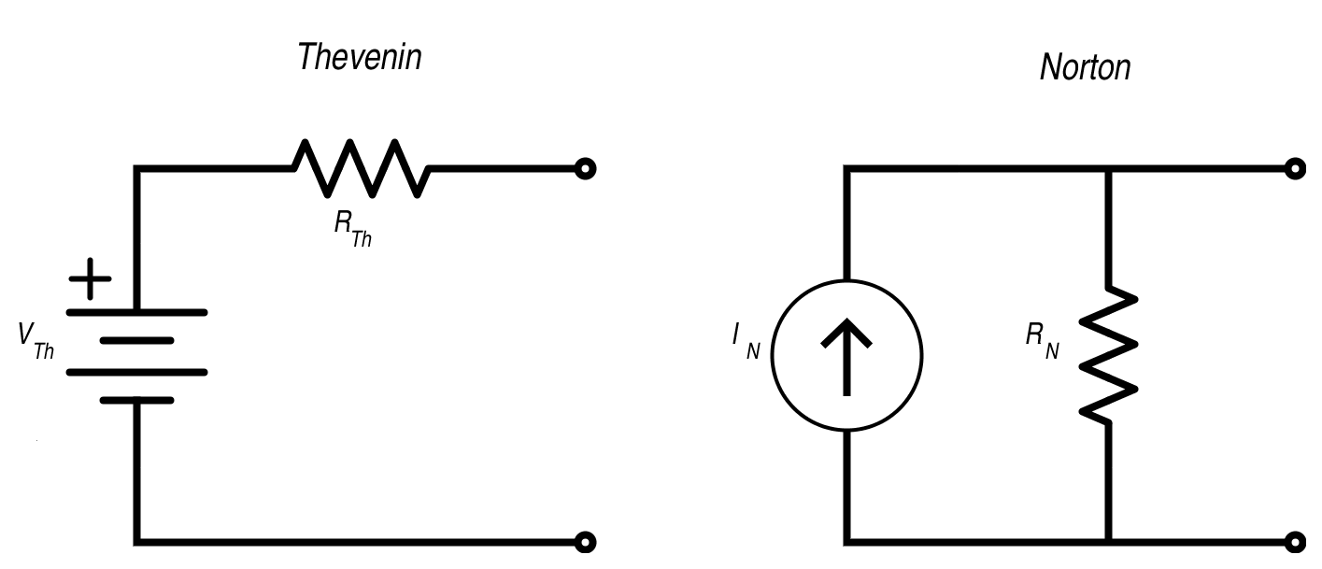

ECE 1101 Lab, Section 6

Date: Thursday, September 26th, 2019

Kyler Martinez, Daniel Tan

Equipment Used In The Experiment:

* Fluke Digital Multimeter
  + Make/Model: 8010A
  + Serial Number: 56708
* Keysight 4 ½ Digital Display Multimeter
  + Make/Model: U3401A
  + Serial Number: MY56150032
* Keysight Triple Output DC Power Supply
  + Make/Model: E3630A
  + Serial Number: MY56186189

Materials Used In The Experiment:

* Breadboard
* 1kΩ Resistor
* 3.3kΩ Resistor
* 6.8kΩ Resistor
* 4.7kΩ Resistor
* 10kΩ Potentiometer

Objective:

The objective of the lab is to determine the Norton and Thevenin equivalent circuits by using a circuit on a breadboard and a potentiometer as a variable resistor. We are then to discover the maximum power condition of our circuit.

Background Theory:

The theory is that a circuit with probes exiting the circuit can be simplified to a Norton or Thevenin equivalent circuit no matter the complexity of the inner circuit. Another part of the theory is that the maximum power condition occurs when the resistance of the resistor outside of the inner circuit is equal to the Thevenin/Norton resistance. Finally the Thevenin and Norton resistance should theoretically be equal, however, our lab should show differently.

Procedure:

We first measured the resistance of our resistors and then configured our circuit board to look like the circuit displayed in figure 1. To find the Thevenin voltage we have to measure the voltage drop between nodes A and B and to find the Thevenin resistance, we have to use the potentiometer and adjust the resistance until it reaches half of its original value. The resistance of the potentiometer will equal RTh. Finally, to find the max power condition, use an ammeter and measure the voltage and current at different voltages and then create a graph and find the resistance when the graph reaches a maximum value.

To find the Norton current we create a short between nodes A and B and then measured the current going through the ammeter. To find the Norton resistance we then removed the short and adjusted the potentiometer until the current was half of its original value and then measured the resistance of the potentiometer.

Data:

Resistor Values

|  |  |  |  |  |
| --- | --- | --- | --- | --- |
| Resistor | 6.8 kΩ | 1 kΩ | 3.3 kΩ | 4.7 kΩ |
| Measured Resistance | 6.771 kΩ | 0.9939 kΩ | 3.2977 kΩ | 4.655 kΩ |

Measurements

|  |  |  |  |  |
| --- | --- | --- | --- | --- |
| Measured Values | ETh= 4.0313 V | RTh= 1.952 kΩ | IN= 2.11 mA | RN=1.9 kΩ |
| Calculated Values | ETh= 4.03096 V | RTh= 1.910 kΩ | IN= 2.1198 mA | RN=1.910 kΩ |
| % Discrepancy | .009 % | 2.19% | .4623 % | .523% |

System of Equations to Calculate VA

(Vc-E)/R1 + (Vc)/R2 + (Vc-VA)/R3 = 0 (VA-Vc)/R3 + (VA-E)/R4 = 0

The equation to Calculate RN/RTh

RN=RTh=ETh/IN

System of Equations to Calculate IN

(3.2977 k+6.771 k)i1-(6.771 k)iN-(3.2977 k)i3=5 (6.771 k+0.9939 k)iN-(6.771 k)i1-i3(0.9939 k)=0

(3.2977 k+4.655 k+0.9939 k)i3-(3.2977 k)i1-(0.9939 k)iN=0

Maximum Power Condition

|  |  |  |  |  |  |  |
| --- | --- | --- | --- | --- | --- | --- |
| V (V) | 2.1955 | 2.5188 | 2.973 | 3.8116 | 1.18 | 1.31 |
| I (mA) | 1.25 | 1.11 | .91 | .53 | 1.71 | 1.65 |
| V*I (mW) | 2.744375 | 2.795868 | 2.70543 | 2.020148 | 2.0178 | 2.1615 |
| R=V/I (k𝝮) | 1.7564 | 2.26918 | 3.26703 | 7.19169 | .69005 | .79393 |

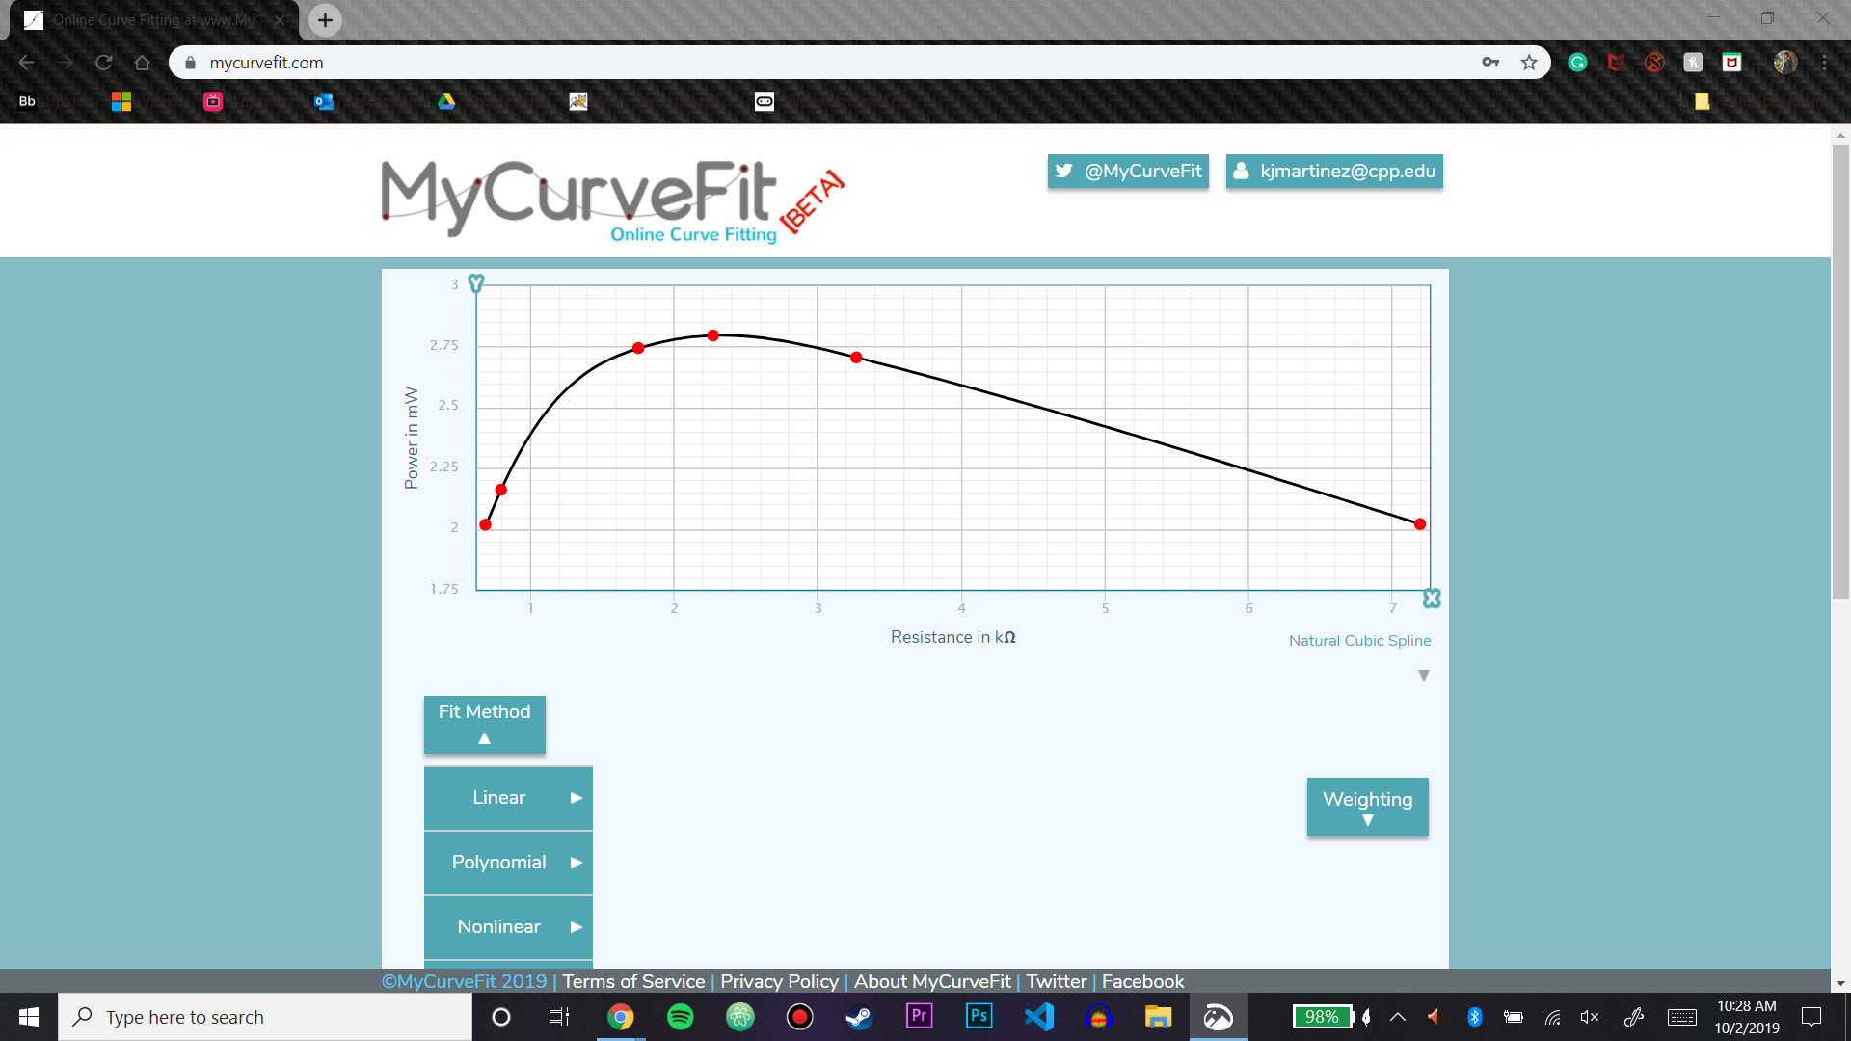

Conclusion:

Overall we had low variations with the biggest was between the calculated Thevien resistance and the measured, however, the difference wasn’t too large nevertheless. Even though the Norton and Thevien resistance is supposed to be theoretically equally, our measurements showed an about 1.3 % difference between the two and this can be attributed to how the measurements were gathered. The Norton resistance was found by adjusting the current through an ammeter and the Theviene resistance was found by adjusting the voltage using a voltmeter. Due to using different measuring devices the values could be expected to have been different due to the techniques used. Most of the percent error we could attribute to human error with the potentiometer since the potentiometer is difficult to adjust accurately since slight adjustments can change the resistance by a fair amount. Due to this, we had to accept some values as “close enough” and had difficulty adjusting the potentiometer so that the voltmeter and ammeter read the values that we were looking for.

After creating the graph for the maximum power condition, we confirmed that the max power occurred around the Thevenin resistance, however our reproduced data that had the max around 2.269 k𝝮. The percent error for this is about 16.2%, however, our data showed a graph that appeared to be similar to the maximum power condition graph. We could have forgotten to unplug or accidentally had a circuit element make contact with another which could have thrown our numbers off. During the lab, we were running out of time and were making our measurements with haste which could have led to an accident occurring since we weren’t as careful while trying to finish the lab.

**Post Lab #5**

PSpice Simulation

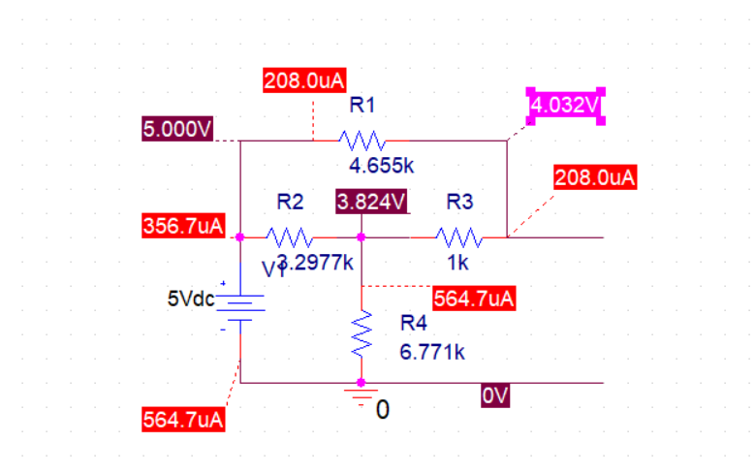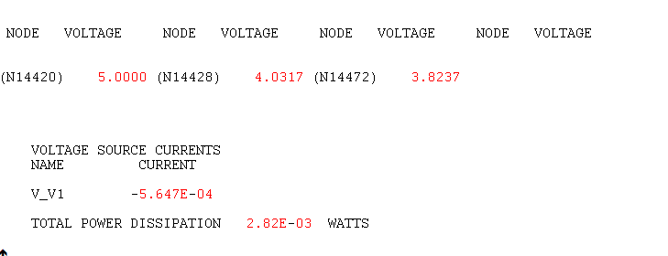

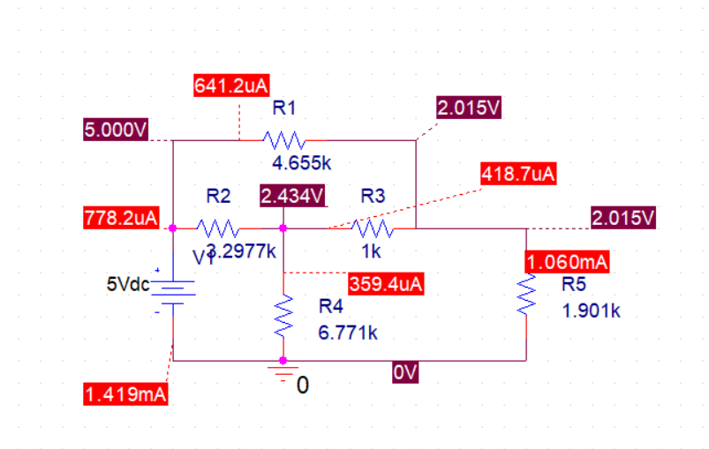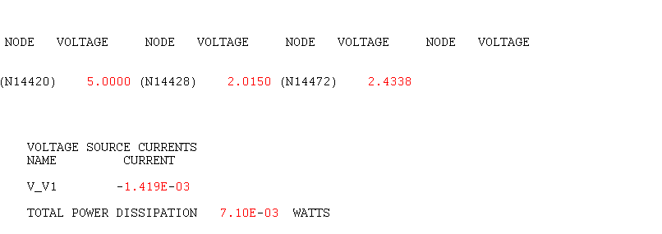

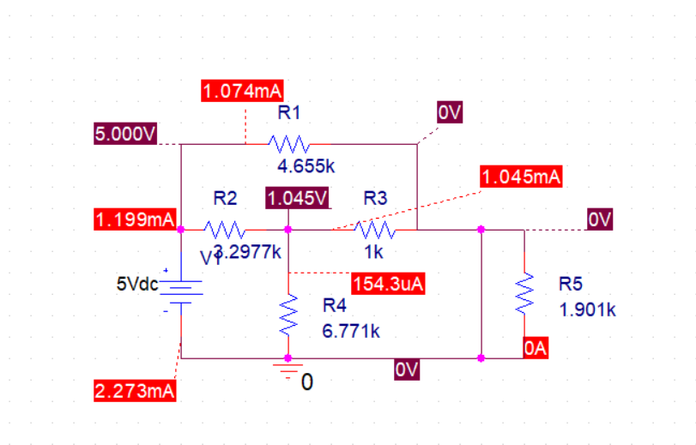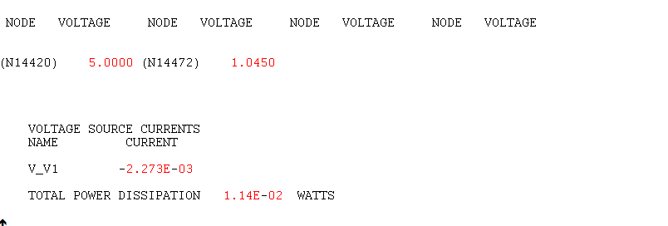

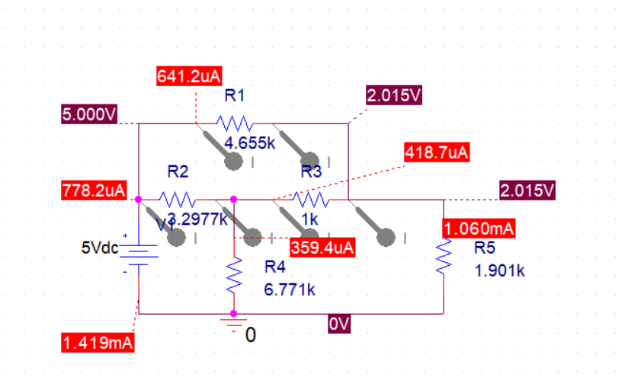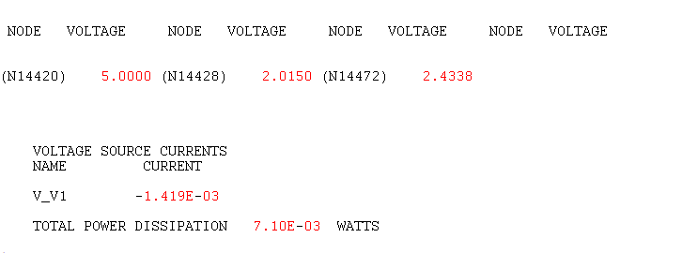

System of Equations to Calculate VA

(Vc-E)/R1 + (Vc)/R2 + (Vc-VA)/R3 = 0 (VA-Vc)/R3 + (VA-E)/R4 = 0

The equation to Calculate RN/RTh

RN=RTh=ETh/IN

System of Equations to Calculate IN

(3.2977 k+6.771 k)i1-(6.771 k)iN-(3.2977 k)i3=5 (6.771 k+0.9939 k)iN-(6.771 k)i1-i3(0.9939 k)=0

(3.2977 k+4.655 k+0.9939 k)i3-(3.2977 k)i1-(0.9939 k)iN=0

Measurements

|  |  |  |  |  |
| --- | --- | --- | --- | --- |
| Measured Values | ETh= 4.0313 V | RTh= 1.952 kΩ | IN= 2.11 mA | RN=1.9 kΩ |
| Calculated Values | ETh= 4.03096 V | RTh= 1.910 kΩ | IN= 2.1198 mA | RN=1.910 kΩ |
| Simulated Values | ETh= 4.032 V | RTh= 1.901kΩ | IN= 2.12 mA | RN =1.901 kΩ |
| % Discrepancy | .011 % | 1.04% | .312% | .33% |

Conclusion

When comparing our values across the board we had a relatively low error for our Thevenin voltage and our Norton resistance both being below half of a percent. However, our Thevenin resistance had the biggest difference of 1.04% discrepancy for our simulated and measured values. Finally, we used the simulation to find the Norton resistance and knew that the current going through the Thevenin resistance would be half of the Norton current and doubled it to find the Norton current. For the measurements for the Norton current, we got roughly .312% discrepancy among our values.